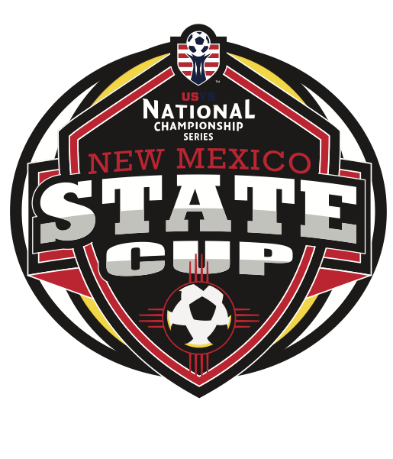

Affidavit for New Mexico Open State Cup Participation

I, Team Coach / Team Manager. in my capacity as the Team Manager of [Team Name], hereby affirm the following points in compliance with the regulations set forth by the New Mexico Youth Soccer Association (NMYSA) for participation in the State Cup:

- Copies of Player Membership/Medical Release Paperwork and Birth Certificates:
  - I confirm that our team possesses copies of all necessary player membership and medical release paperwork, as well as birth certificates for each player on the roster.
- International Clearance Paperwork:
  - We have adhered to the current International Transfer Clearance (ITC) Guidelines as outlined on nmysa.net for any players requiring international clearance.
- Signed Playing Up Release Forms:
  - I attest that all necessary Playing Up Release Forms have been appropriately signed by the relevant parties, in accordance with Section 2 (B) of the US Youth National Championship Series Policy for the 2023/2024 season.
- Verification of Appropriate Coaches on Team Roster:
  - It is confirmed that only coaches listed on the team roster will be permitted on the sidelines during State Cup games, as per the regulations stipulated by NMYSA.
- Distribution of NMYSA "Zero Tolerance Policy" to Parents:
  - Our team has ensured the distribution of the NMYSA "Zero Tolerance Policy" to all parents, and we affirm that they understand the policy as stated.

I hereby certify that the information provided above is true and accurate to the best of my knowledge. I understand that any falsification or misrepresentation may result in disciplinary action against our team as per NMYSA regulations.

Team Coach / Manager: Signature Date:

Team Coach / Manager: Printed

Contact Phone # Team Name:

New Mexico Youth Soccer Association
2825 Broadbent Parkway NE, Suite D
Albuquerque, NM 87107 USA

