The governing body for youth soccer in New Mexico, affiliated with US Youth Soccer,

the United States Soccer Federation (USSF), and the Fédération Internationale de Football Association (FIFA)

**CREDENTIALS REPORT**

Tournament:

Date(s):

Number of teams in tournament:

Number of NMYSA teams checked in: Number of out-of-state teams checked in: Number of other teams checked in:

List problems / corrections you made with the NMYSA teams:

*(be specific giving all the information possible)*

List problems / corrections you made with the out-of-state teams or other teams:

*(be specific giving all the information possible)*

Submitted by: Position:

PLEASE FILE THIS REPORT WITH THE TOURNAMENT REPORT. PLEASE SEND A COPY OF THIS REPORT TO THE NMYSA STATE REGISTRAR.

Rev 09/2021

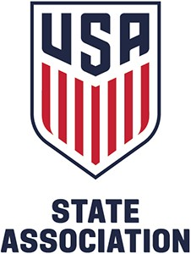**2825 Broadbent Parkway NE, Suite D • Albuquerque, NM 87107**

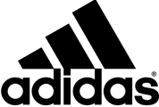Administrative Office: (505) 830-2245 • [office@nmysa.net](mailto:office@nmysa.net) Coaching Department: (505) 830-2246 • [coach@nmysa.net](mailto:coach@nmysa.net) fax (505) 830-2247 • <http://www.nmysa.net/>