**NMYSA/APS Middle School Registration**

Log In/Create an Account: <https://clubs.bluesombrero.com/nmysa> for the **NMYSA/APS Middle School Registration, then select the Middle School attending.**

Click the **Register**button in the top right-hand corner of the portal to create an account.  
If you already have an account, Login and [click here](https://stacksportsportal.force.com/helpcenter/s/article/SportConnectSupportClubProduct360035874692Registration20ParentGuide?b=0011T00002RaROcQAN#h_b7c75de8-fc7e-4756-89f9-e67efe3ccdf6) to skip to the player registration steps.

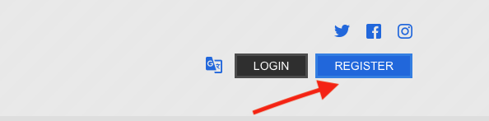Add the appropriate information, then click "Create Account".

If your username/password combination is accepted, you'll see the screen below. Select the image on the left to register a participant for a program.

Fill out the [Account Holder Information](https://clubs.bluesombrero.com/Portals/1824/Images/Screen%20Shot%202019-11-21%20at%2012.17.19%20AM.png) section. If you wish to add an Additional Parent/Guardian, enter their information and click Invite Account User & Continue. If not, leave the area blank and click Continue**.** Now that your account has been created, continue to Register the Player.

**Registering Players**

If this is your first time registering a player, you'll see the image below.

Select the appropriate number of players, then begin filling out their registration information. *Please be sure to select the appropriate Date of Birth and Gender fields - these are the parameters that decide which programs/divisions are available for registration*

*Fields marked with an asterisk are required

After entering Player Information, select the appropriate available activity:

Use the View Description link for more information about the available Programs.

After selecting a Program/Division, fill out the rest of the questions required by your organization and continue to the next step.

## Existing User Instructions:

After logging in, click the Available Programs button next to the appropriate player to register a player.